GARAGE MANAGEMENT SYSTEM

COLLEGE NAME: GOVERNMENT ARTS COLLEGE

COLLEGE CODE: BRU09

TEAM ID:

TEAM MEMBER:

TEAM LEADERNAME: S.Niranjan

EMAIL:niranjanmalathi2005@gmail.com

TEAM MEMBER1: J.Gowtham raj

EMAIL: gowthamraj1352005@gmail.com

TEAM MEMBER2:G.Akash

EMAIL: akaskkuna1235@gmail.com

TEAM MEMBER3:S.Praveen kumar

EMAIL: [praveenkumar1432006@gmail.com](mailto:praveenkumar1432006@gmail.com)

INTRODUCTION:

The Garage Management System is a software application developed to automate garage operations such as vehicle servicing, mechanic allocation, billing, and customer management. The system provides a centralized platform where customers can book services, mechanics can update service status, and admins can generate bills and reports. This reduces manual work, saves time, and increases efficiency in garage operations

PROJECT OVERVIEW:

The Garage Management System is a software application designed to computerize and streamline the operations of a garage or vehicle service center. Traditionally, garages rely on manual record-keeping, which is time-consuming, prone to errors, and inefficient. This project aims to replace those manual methods with a digital platform that simplifies customer management, vehicle tracking, service booking, mechanic allocation, billing, and inventory control.

The system provides an easy-to-use interface for administrators, mechanics, and customers. Customers can register and book services, while the admin can manage mechanics, allocate jobs, and generate bills. It also maintains a history of vehicle services, helping both the garage staff and customers track repairs and maintenance.

By automating the entire workflow, the Garage Management System ensures faster service, accurate billing, reduced paperwork, and improved customer satisfaction. It also offers reporting features to help garage owners analyze performance and make better business decisions

OBJECTIVES:

The main objective of the Garage Management System is to automate and streamline garage operations by providing a digital platform for managing customers, vehicles, services, mechanics, and billing.

Specific objectives include:

1. To maintain accurate records of customers and their vehicles.

2. To enable easy booking and tracking of vehicle services.

3. To allocate jobs to mechanics efficiently and monitor their work.

4. To generate bills and invoices automatically, reducing manual errors.

5. To manage spare parts and inventory effectively.

6. To provide service history and reports for better decision-making.

7. To improve overall customer satisfaction through faster and reliable service.

ER DAIGRAM:

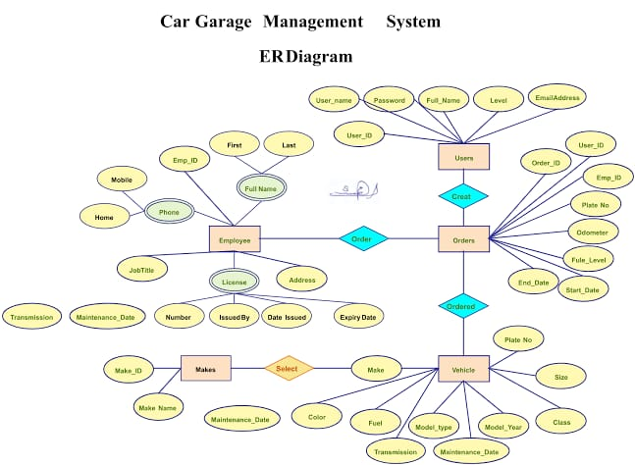

PURPOSE:

The purpose of the Garage Management System is to digitize and simplify the daily operations of a garage or vehicle service center. Instead of maintaining records manually, this system provides a computerized solution to manage customers, vehicles, services, billing, and inventory in an efficient way.

Key Purposes:

1. Automation of Garage Activities – To reduce manual work by automating booking, service tracking, and billing.

2. Customer Management – To store and maintain accurate customer and vehicle records.

3. Mechanic Allocation – To assign jobs to mechanics and monitor their performance.

4. Billing and Invoicing – To generate bills quickly with accuracy.

5. Inventory Tracking – To manage spare parts and stock levels.

6. Service History Maintenance – To keep a record of past services for easy reference.

7. Decision-Making Support – To provide reports and analytics for better management.

8. Customer Satisfaction – To improve service quality by providing fast, error-free, and transparent operations

DEVELOPING PHASE

CREATING DEVELOPER ACCOUNT:

By Using this URL - <https://www.salesforce.com/form/developer-signup/?d=pb>

OD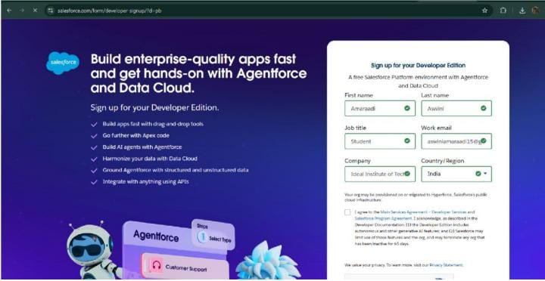

MODULES:

* Salesforce
* Objects
* Tabs
* The Lightning App
* Fields
* Validation Rule
* Duplicate Rule
* Profiles
* Role&Role Hierarchy
* Users
* Public Groups
* Sharing Setting
* Flows
* Apex Trigger
* Reports
* Dashboards
* User Adoption
* OBJECTS:

Created Objects: Appointment,service record, Billing details and feedback

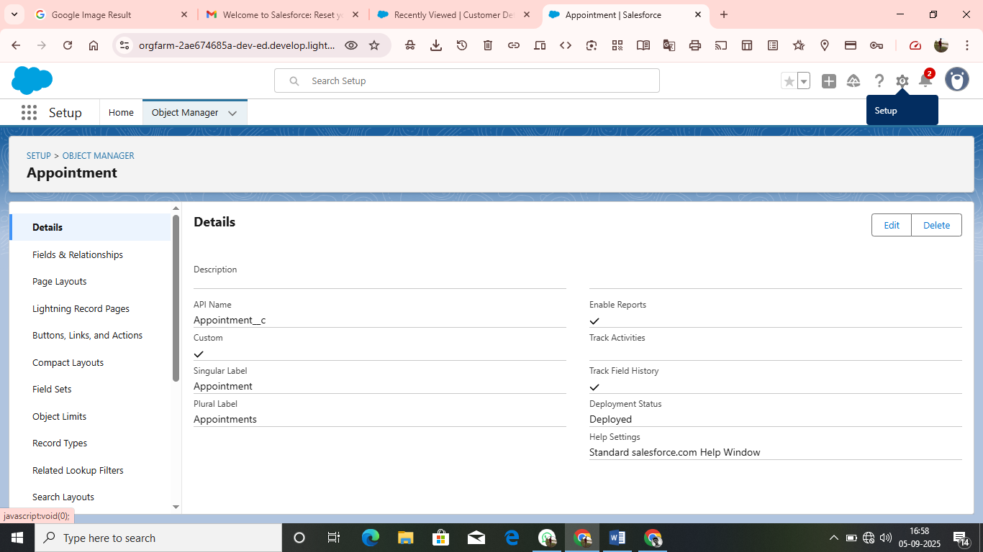

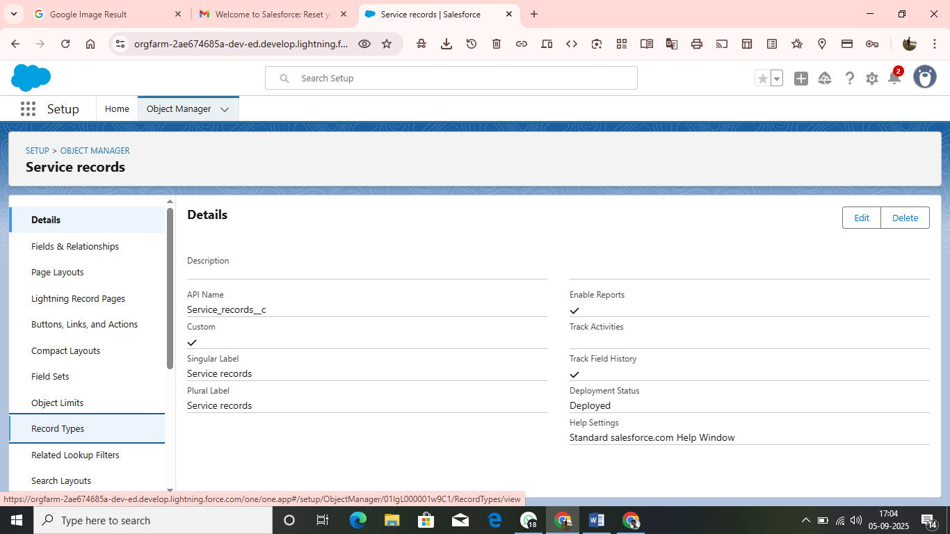

* TABS:

A Tab is like a user interface that is used to build records for objects and to view the records in the object

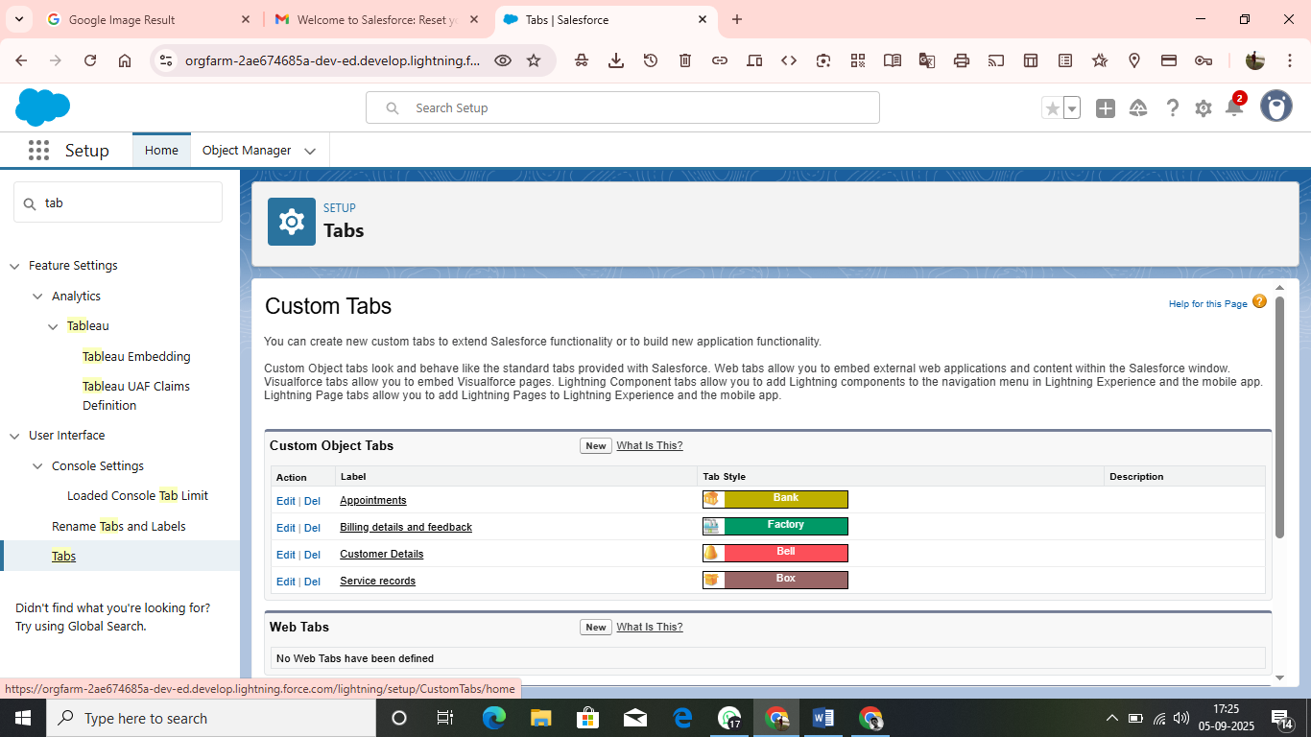

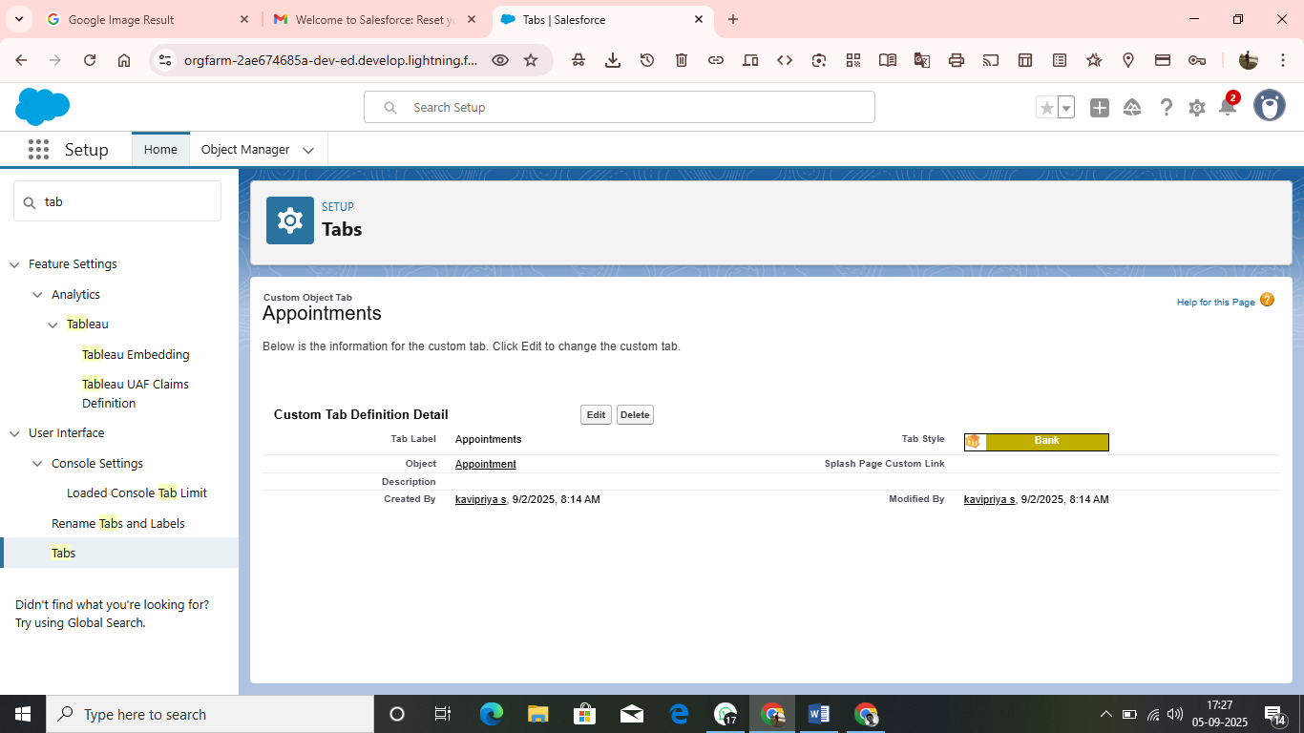

* THE LIGHTNING APP:

An app is a collection of items that work together to serve a particular function. In Lightning Experience, Lightning apps give your users access to sets of objects, tabs, and other items all in one convenient bundle in the navigation bar.

Lightning apps let you brand your apps with a custom colour and logo. You can even include a utility bar and Lightning page tabs in your Lightning app. Members of your org can work more efficiently by easily switching between apps.

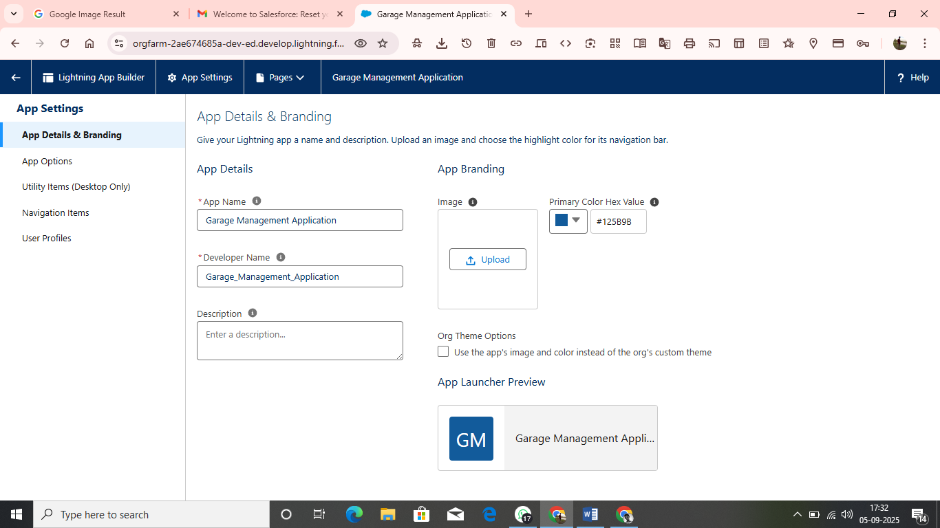

* FIELDS:

Fields represent the data stored in the columns of a relational database. It can also hold any valuable information that you require for a specific object. Hence, the overall searching, deletion, and editing of the records become simpler and quicker.

Types of Fields

* Standard Fields
* Custom Fields

STANDARD FIELDS:

As the name suggests, the Standard Fields are the predefined fields in Salesforce that perform a standard task. The main point is that you can’t simply delete a Standard Field until it is a non-required standard field. Otherwise, users have the option to delete them at any point from the application freely. Moreover, we have some fields that you will find common in every Salesforce application. They are,

Created By

Owner

Last Modified

Field Made During object Creation

CUSTOM FIELD:

On the other side of the coin, Custom Fields are highly flexible, and users can change them according to requirements. Moreover, each organiser or company can use them if necessary. It means you need not always include them in the records, unlike Standard fields. Hence, the final decision depends on the user, and he can add/remove Custom Fields of any given form.

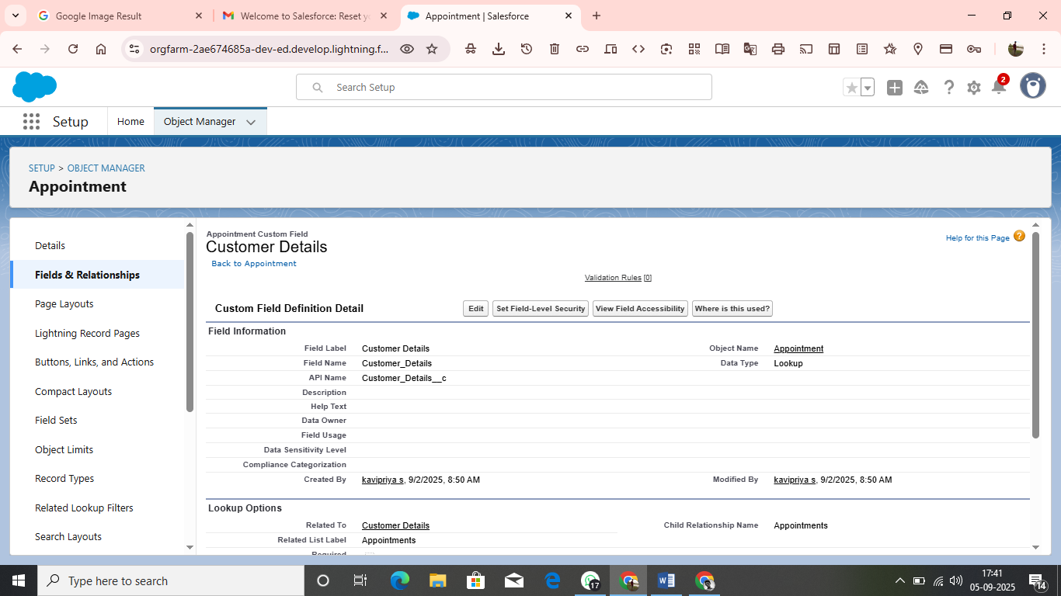

* VALIDATION RULE:

Validation rules are applied when a user tries to save a record and are used to check if the data meets specified criteria. If the criteria are not met, the validation rule triggers an error message and prevents the user from saving the record until the issues are resolved.

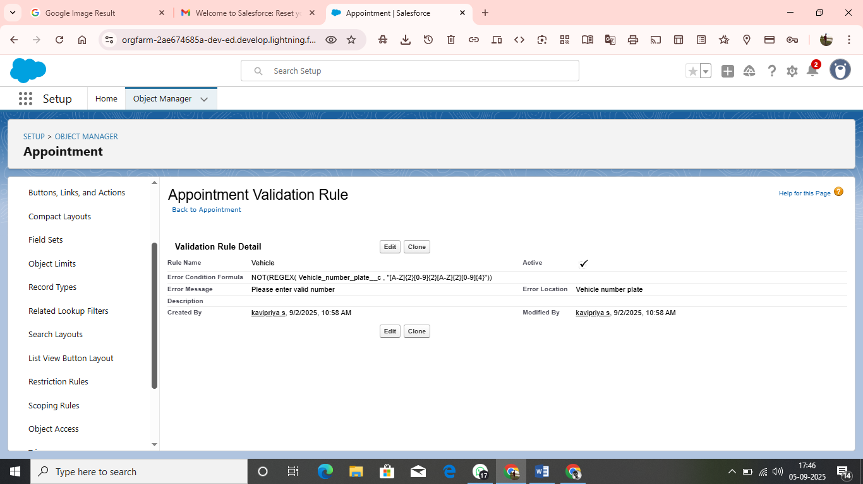

* DUPLICATE RULE:

1.go to quick find box in setup and search for matching rules

2.click on matching rules

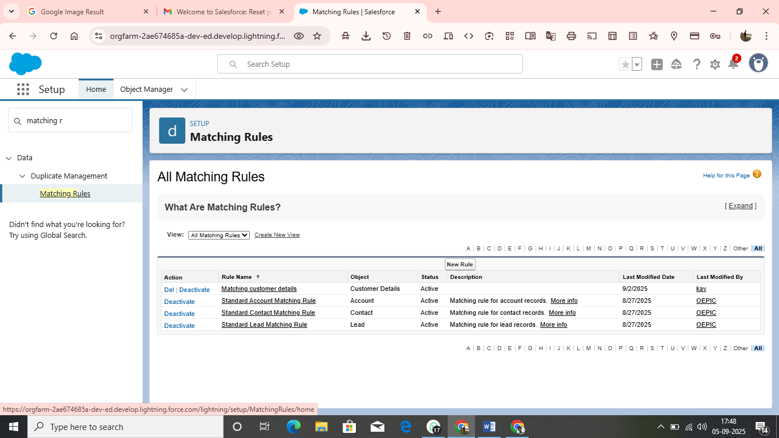

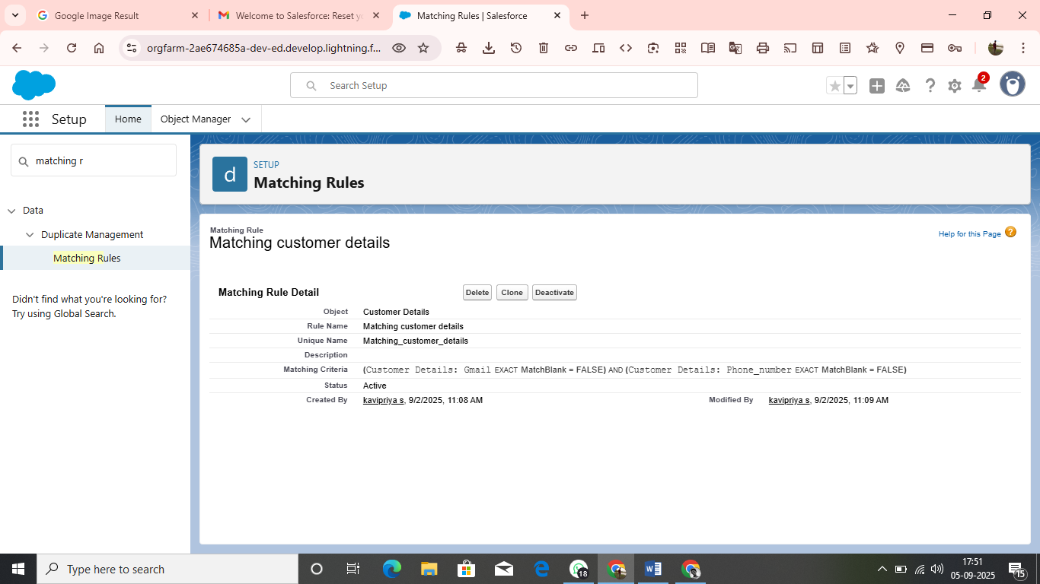

* PROFILES:

A profile is a group/collection of settings and permissions that define what a user can do in salesforce. Profile controls “Object permissions, Field permissions, User permissions, Tab settings, App settings, Apex class access, Visualforce page access, Page layouts, Record Types, Login hours & Login IP ranges. You can define profiles by the user's job function. For example System Administrator, Developer, Sales Representative.

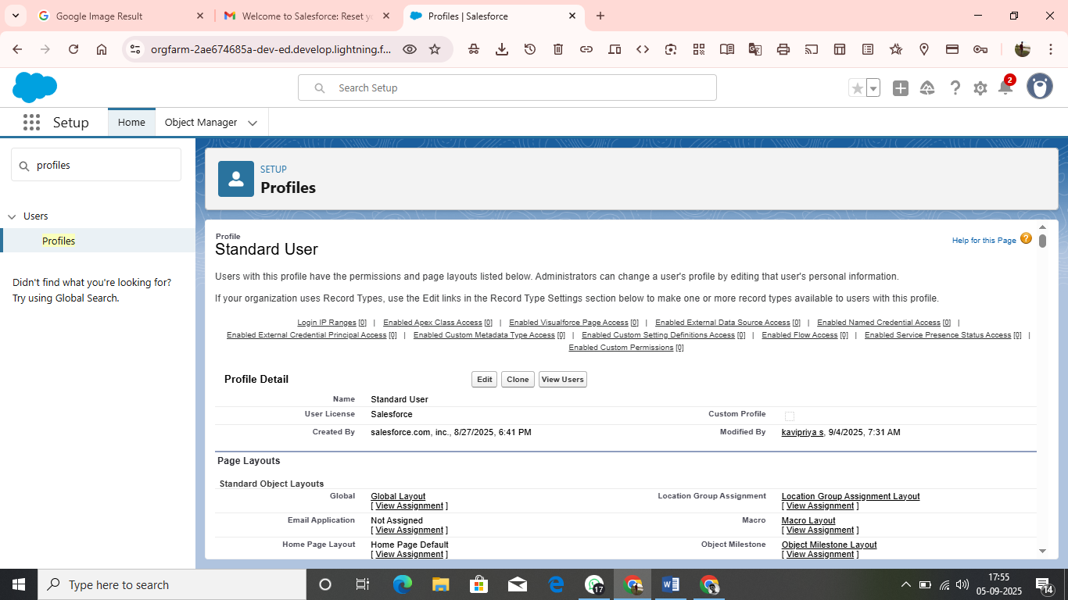

* ROLE&ROLE HIERARCHY:

A role in Salesforce defines a user's visibility access at the record level. Roles may be used to specify the types of access that people in your Salesforce organization can have to data. Simply put, it describes what a user could see within the Salesforce organization.

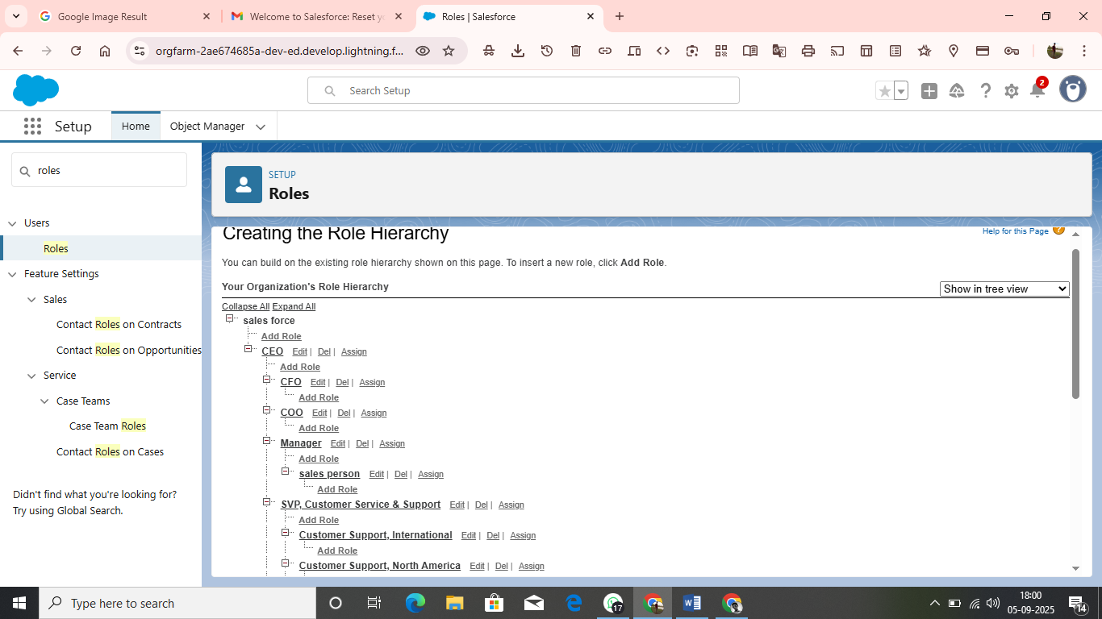

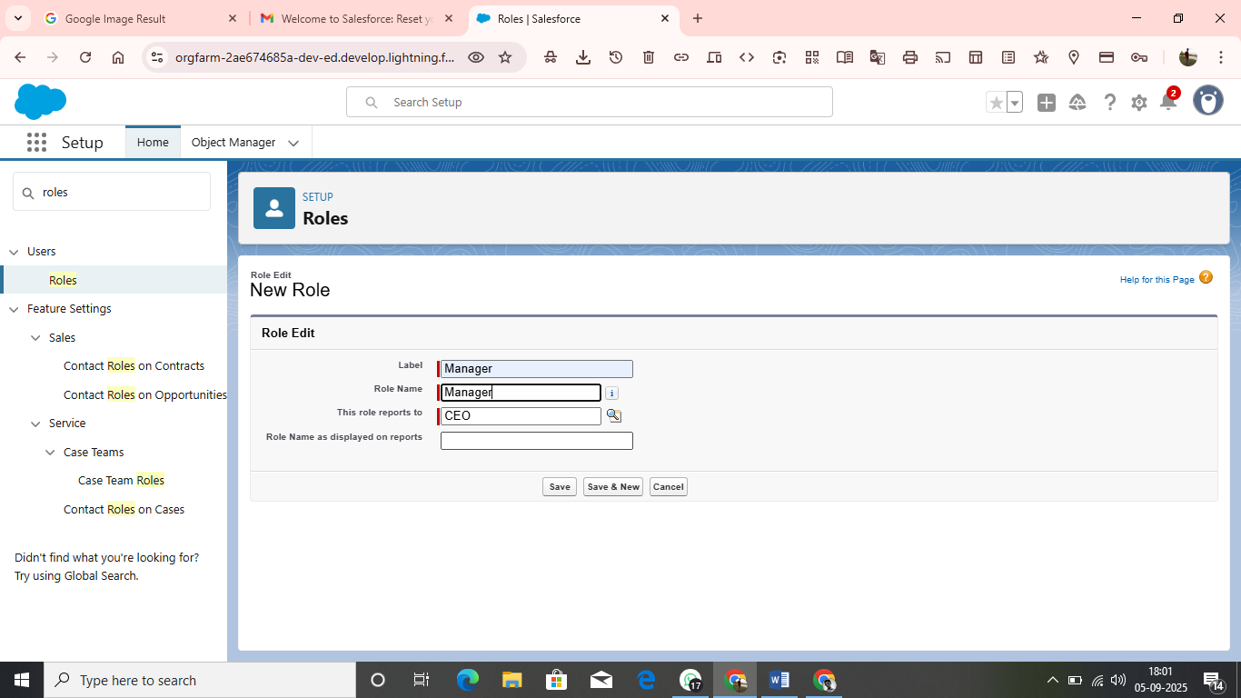

* USERS:

A user is anyone who logs in to Salesforce. Users are employees at your company, such as sales reps, managers, and IT specialists, who need access to the company's records. Every user in Salesforce has a user account. The user account identifies the user, and the user account settings determine what features and records the user can access.

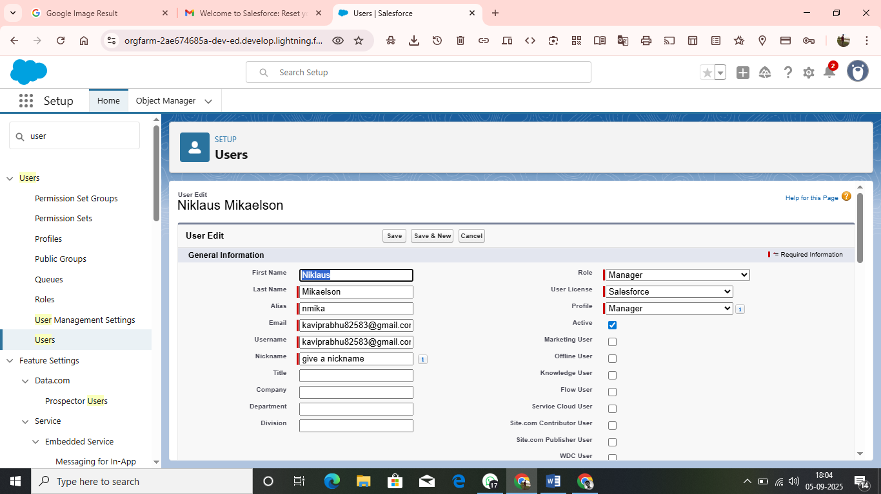

* PUBLIC GROUPS:

Public groups are a valuable tool for Salesforce administrators and developers to streamline user management, data access, and security settings. By creating and using public groups effectively, you can maintain a secure and organized Salesforce environment while ensuring that users have appropriate access to the resources they need.

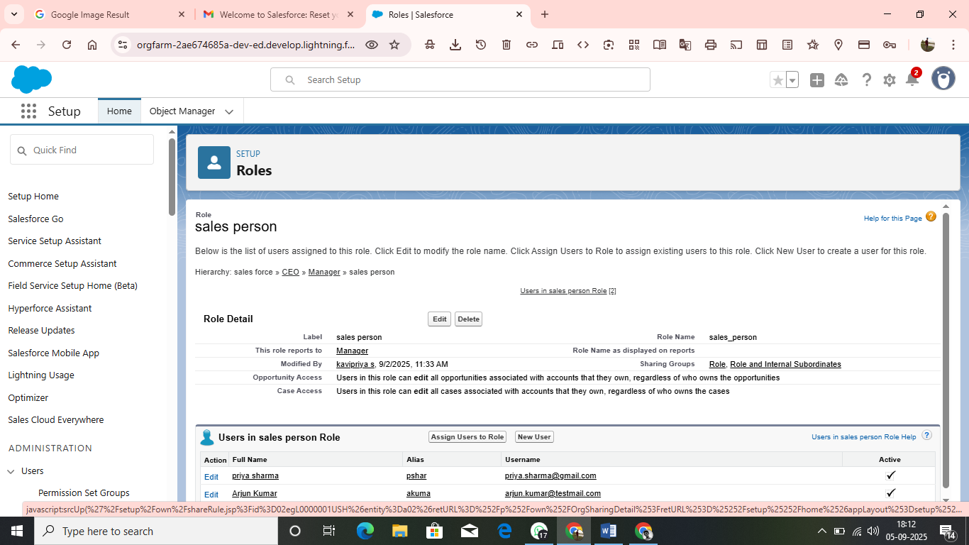

* FLOWS:

A flow is a powerful tool that allows you to automate business processes, collect and update data, and guide users through a series of screens or steps. Flows are built using a visual interface and can be created without any coding knowledge.

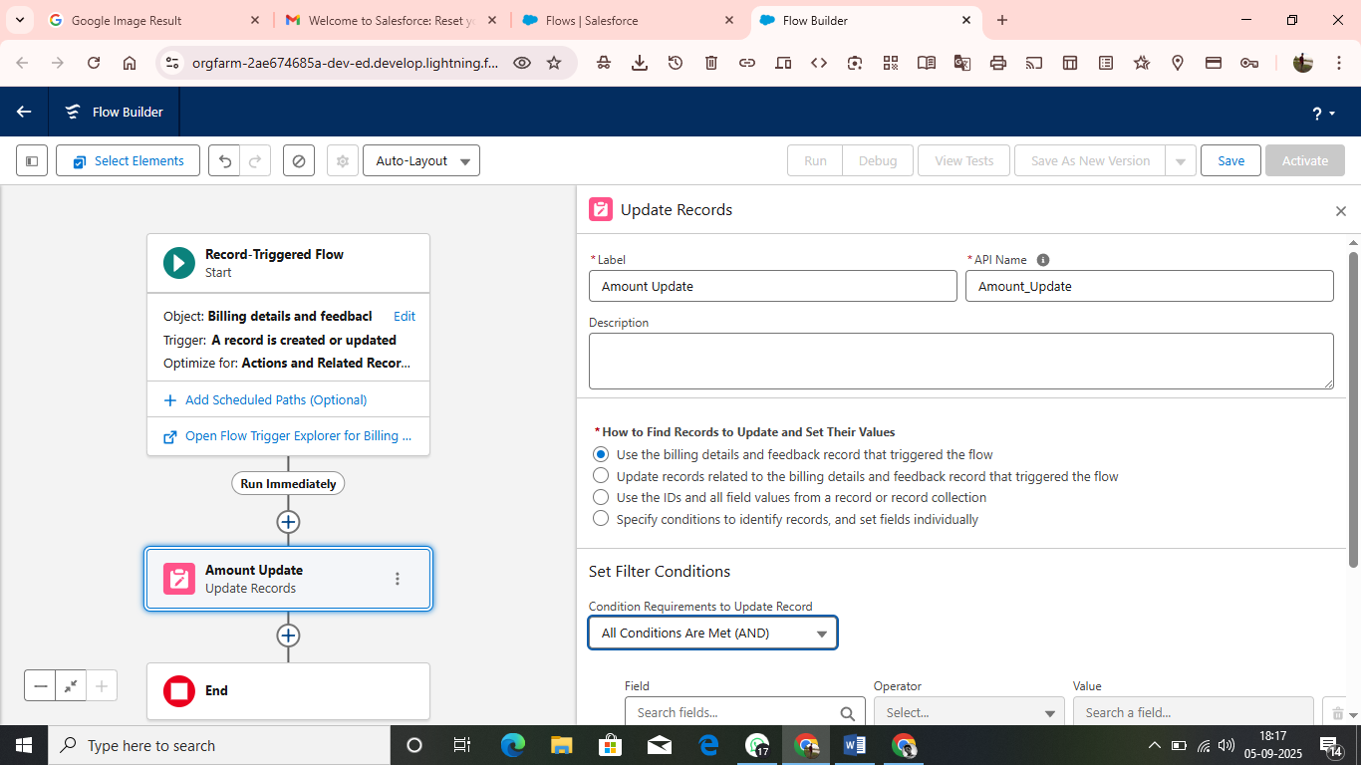

* APEX TRIGGER:

Apex can be invoked by using triggers. Apex triggers enable you to perform custom actions

before or after changes to Salesforce records, such as insertions, updates, or deletions.

A trigger is Apex code that executes before or after the following types of operations:

insert

update

delete

merge

upsert

undelete

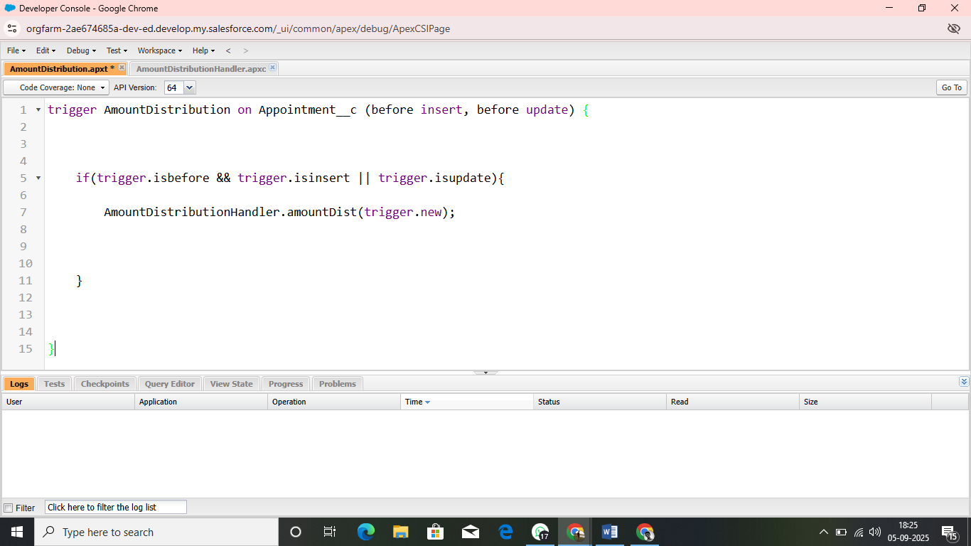

* REPORTS:

Reports give you access to your Salesforce data. You can examine your Salesforce data in almost infinite combinations, display it in easy-to-understand formats, and share the resulting insights with others. Before building, reading, and sharing reports, review these reporting basics.

Types of Reports in Salesforce

Tabular

Summary

Matrix

Joined Reports

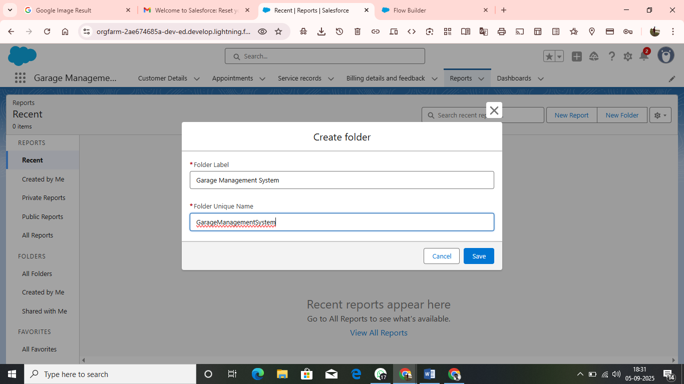

* DASHBOARDS:

Dashboards help you visually understand changing business conditions so you can make decisions based on the real-time data you’ve gathered with reports. Use dashboards to help users identify trends, sort out quantities, and measure the impact of their activities. Before building, reading, and sharing dashboards, review these dashboard basics.

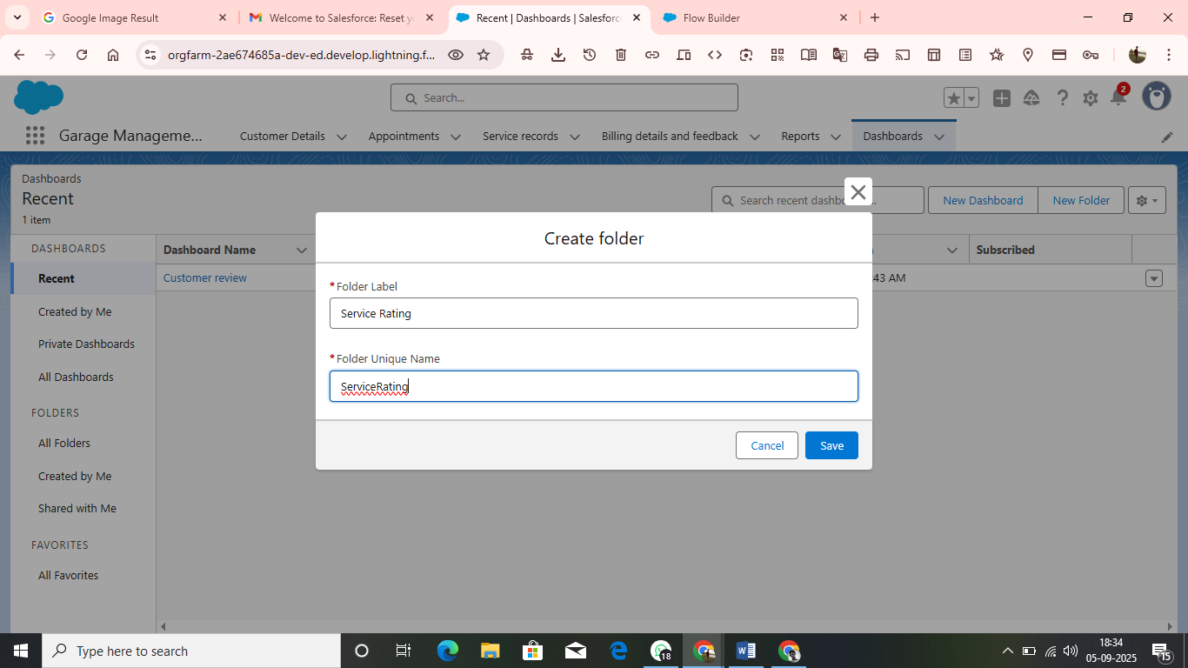

* USER ADOPTION:

